JOINT ADVANCED STUDENT SCHOOL 2008, ST. PETERSBURG

Noise and Vibration Control

Final Report by

Maxim Afanasyev

born on 11.03.1986

address:
Grazhdanski pr. 28
Saint-Petersburg, Russia
Tel.: +79217537732

Department of

DISTRIBUTED INTELLIGENT SYSTEMS

Saint-Petersburg State Technical University

Supervisor: Potehin V.V.
Submitted: 01.03.2008

Introduction

The main idea of this article is to tell you about the work which was done in our university and which was devoted to noise reduction in habitable compartment of international space station. But before talking about it I would like to tell you about other things closely connected to my topic.

The study of sound and it’s “friend” noise is closely related to the study of vibration, and as soon as these two matters have the same nature, vibrating structures generate sound and sound, “producing” pressure waves can generate vibration of structures. When trying to reduce noise it is often a problem in trying to reduce vibration. That’s why we should speak about noise when speaking about vibration and vibration is worth speaking when talking about noise.

Vibration and sound are occasionally desirable, for instance the music that you listen to, the motion of the tuning fork or a reed, but more often, vibration is undesirable, wasting energy and creating unwanted sound – noise! Vibration and sound can be very dangerous! They can be harmful for different equipment, machinery and other staff but the worst thing happen when these affect humanbeings.

But before exploring these affects let’s explore what is vibration and sound?

Sound and Vibration Theory

Vibration is The repetitive variation, typically in time, of some measure about a central value or between two or more different states. It is mechanical oscillations about an equilibrium point. Oscillations can be periodic(for instance the movement of pendulum) or random. Another name for Oscillations is waves. They can be Longitudinal -waves that have vibrations along or parallel to their direction of travel, that is, waves in which the motion of the medium is in the same direction as the motion of the wave. And transverse wave- wave that propagates in a direction perpendicular to the direction in which the oscillations that produce the wave are moving. Wave-is the main connecting link between vibration and sound, which physically is vibrational mechanical energy that propagates through matter as a wave and can travel through gases, liquids, solids except for vacuum! Sound waves are characterized by the generic properties of waves, which are frequency, wavelength, period, amplitude, intensity, speed, and direction (sometimes speed and direction are combined as a velocity vector, or wavelength and direction are combined as a wave vector). Transverse waves, also known as shear waves, have an additional property of polarization. Another very important feuture is sound pressure level which is the difference between the actual pressure in the medium and the average, or equilibrium pressure of the medium at that location. It can be measured by microphone in air and hydrophone in water.

Negative Influence

The speed of technics development is very high nowadays and this makes it almost imposible to avoid contacts with different high speed, powerful mechanisms which leads to contacting with wide variety of vibrational and sound fields. For humans, hearing is limited to frequencies between about 20 Hz and 20000 Hz, with the upper limit generally decreasing with age. Other species have a different range of hearing. For example, dogs can perceive vibrations higher than 20 kHz. As a signal perceived by one of the major senses, sound is used by many species for detecting danger, navigation, predation, and communication. Losing the ability to hear is quite normal too. But only as I already said when getting older. We think of Noise as a disturbing, unwanted sound. Along with vibration, such sound can bring much harm to a person's health. An increased noise level affects both the auditory apparatus (with specific changes) and the whole body of a person (with non-specific changes). In fact, after the years working in an environment elevated noise, people complain about hearing deterioration, while after ten years they may acquire such diseases as neuritis of the auditory nerve. In high sound pressures (140 dB or more) immediate damage of the auditory apparatus may occur. Non-specific noise produces effects, first of all, in disturbances of the nervous, heart and blood vessel. In continuous noise conditions one may acquire irritability, apathy and indifference, feelings of depression; also sometimes memory loss and blood pressure increases can also occur. Noise also affects people in the following ways: delayed mental reactions, decreased rate of work, deterioration in quality of processing data. Noise reduces manufacturing efficiency, cutting it down by 5-20%. A noise level increase of 1 dB above normal is considered to result in a 1% decrease in output.

In Germany the influence of noise on the work efficiency of building machine operators has been investigated. A particular conclusion was reached that a reduction of the sound level from 96 to 86 dB(A) resulted in an increase in the work efficiency of excavator drivers by 12%.

NOISE REDUCTION IN HABITABLE COMPARTMENT OF INTERNATIONAL SPACE STATION

The noise in habitable compartments of manned space vehicles, considerably exceeds the normative values adopted according to standard SSP 50094. The acoustic discomfort which is experienced by astronauts, has an adverse effect on their health and functionability. So, for example, in view of purpose of the International Space Station(MCS), crews should conduct there enough the large period of time, i.e. conditions of flight can be counted continuous (over 30 day). The unique way of normalisation of a
noise on space objects is a reduction of noise sources of and increase of dissipative properties of designs and constructions due to additional vibration-damping and the sound-absorbing linings. Effectiveness of those or other means of noise reduction for a design stage of object is one of research problems. First of all it is necessary to reveal noise sources and to determine their influence on formation of a sound field in habitable compartments. The mathematical model of calculation of an expected noise is developed on an example of the International Space Station which includes some modules everyone incorporates the equipment radiating a noise and, hence, bringing contribution to formation of a sound field both in this and other modules. The increased noise and vibration levels are the factors influencing at health, serviceability and psychological condition of crews of manned space vehicles. These factors as have appreciable an effect on the equipment of stations, realization of experiments
and researches. For example, noise levels onboard International Space Station Mir achieved 70 dB(A). Noise should be reduced by fixing rustling equipment by the short periods. The noise level on other manned space vehicles achieved accordingly 65-75 dB(A). Noise level in the inhabited module of International Space Station by results of measurements achieved 74 dB(A) and at working period of velosimulator or vacuum cleaner 75 and 78.6 dB(A) accordingly that considerably exceeds the normative values accepted according to standard SSP 50094. Also influence of noise deforms speech communication and useful signals. The inhabitancy should be convenient and safe for crew. Observance of recommendations for noise and vibration levels is necessary for effective decision of tasks during flight by astronauts. Therefore it is necessary to develop recommendations and the offers directed on effective designing, development and completion of the inhabitancy of the space stations. The main noise and vibration sources at the space station are life-support and environment control systems including fans, pumps, air filters, dust absorbers and other equipment. These sources of noise work continuously. Besides there are units which create additional noise having faltering character. Fans, pumps and the valves concern to them, included in the equipment soul and systems of gathering of waste products.
Liquid regulators of pressure and gas or liquid streams bring the contribution in noise conditions. At last, the jet control system also may create significant variable noise. Character of a spectrum in space station both on level and on frequency is practically identical. It speaks that large number of simultaneously working equipment in regular intervals located in all station compartments. It creates significant noise even if each noise source has satisfactory acoustic characteristics. The sound field inside space station is complicated with two factors: first the cabin has the elongated form, and second it is connected to transitive compartments and cabins which are not closed. Hence all cabins of station are necessary for considering as unified acoustic space. Thus there is a task of calculation noise characteristics on a design stage in view of influence of a large number of noise sources and allocation of the contribution of everyone to sound field.

DESCRIPTION OF CALCULATED METHODS

Modern vibroacoustics uses some basic approaches for performance of the calculations basing wave, geometrical and statistical theories of acoustics. The wave acoustics observes sound from a position of rigorous physical task. The base wave theory gives an exact picture of sound fields in a room, but it is very difficult and extraordinary rigorous to borders of reflection that makes its difficult and far from practice. The wave theory is frequently applied to the account of resonant phenomena. The geometrical acoustics is more evident, it operates with concept of a sound ray. The flat wave differs that property, that the direction of its propagation and amplitude are identical in space. Certainly, any sound waves have no this property. The sound field represents as the rays constructed under laws of optics. At the big number of re flections geometrical acoustics becomes complicated. Methods of geometrical acoustics are applied if the length of a sound ray more or equal to length of a sound wave. The greatest application for calculations of sound fields in rooms was found with the statistical theory which bases developed known acoustics Sebin. He has connected physical characteristics of the closed volume with engineering methods of calculations. The statistical theory bases on representation of a sound field in the closed volume as diffuse field. Occurrence of a diffuse sound field in a room is caused by presence of the big number of reflections; thus the amplitude and the phase of each reflection do not take into account, and also presence of interferences and resonances is excluded. It allows to apply methods of power summation at calculations, i.e. in any point of a room energetically to summarise Sound Power Level.

MATHEMATICAL MODEL OF NOISE CALCULATION

The mathematical model of calculation of expected noise is developed on an example of the International Space Station which, as is known, includes some modules. Each module includes the equipment radiating noise and, hence, bringing contribution to a sound field both in this module and in to other modules. It is necessary to note that construction of the ISS is not completed. For calculation of an expected noisiness we shall present the ISS as a system consisting of noise sources, channels of propagation of air-borne noise and secondary noise sources. Analysing a functioning of station, we shall note, that sound power of noise sources can be counted constant in time and dependent only from frequency. The real noise sources represent oscillatory systems of the complex shape which calculation of sound fields is difficult. Therefore, applying in calculations of a rule of the statistical theory of acoustics, it is necessary to present noise sources as the simple form radiating flat, cylindrical and spherical sound waves.
Processes of noise formation in the ISS depend on acoustic characteristics of noise sources, their arrangement in relation to specific point, interior panels and their arrangements in relation to the specific point. The total sound pressure level in the specific point from various noise sources can be calculated by equation:

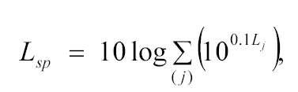
Where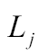 is the sound pressure level from single j-th noise source, dB.

In the closed volume the contribution of each noise sources to formation of sound field in the specific point is determined depending on parameters of a volume and the geometrical sizes of a source, from a directivity of radiation of sources, characteristics of a sound absorption and soundproofing properties of the panels located for a way of sound propagation. In view of it the total sound pressure level can be calculated by following equation:

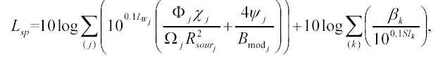

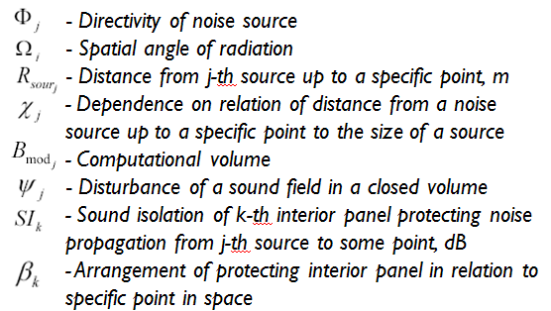

EXPERIMENTAL RESULTS

For comparison of theoretical and experimental results of sound pressure levels the points located along an axis of a module were offered, see Fig. 1. Comparison of theoretical and experimental results has shown a divergence of values within the limits of 1-3 dB in frequency range, that it is possible to count it acceptable. Experimental data of sound pressure level in specific points 1-6 are shown in Fig. 2. As figure show, significant overflow of sound pressure levels are observed in a range of mean and high frequencies.
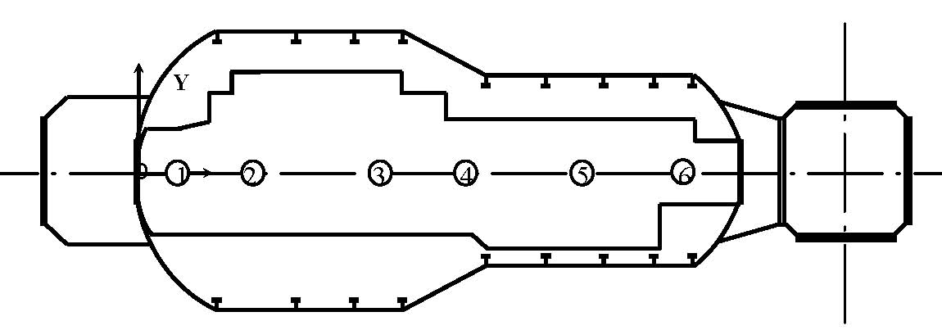

Figure 1. Scheme of location of specific points inside service module of ISS.

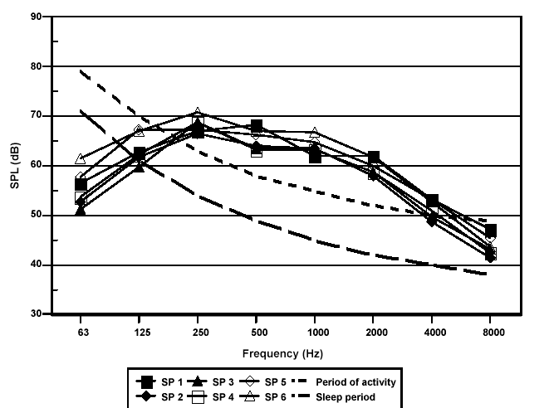

Figure 2. Experimental results of sound pressure levels.

Conclusion

As a result the below listed works have been done:

- Fans changed to less noisy ones
- Air hoses covered with special preventing noise and vibration material
- New interior panels used
Noise was reduced on amount of 4 dB(A), which is stated to be a very good result.

This project still has the area to work at. But besides the results achieved during what was already done, another important approach was made - an idea of new noise limit standards appeared!

REFERENCES

1. Lependin, L.Ph. Acoustics, Moscow, High School, in Russian, (1978).
2. Shcheviev, Yu.P. Architectural-building Acoustics, St. Petersburg, in Russian,
(1996).
3. Ivanov, N.I., and Nikiforov, A.S. The Bases of Vibroacoustics, St. Petersburg,
Politekhnika, in Russian, (2000).
4. Beranek, L.L. Acoustics, Acoustical Society of America through the American
Institute of Physics, Inc., New-York, (1996).
5. Crocker, M.J. Handbook of Acoustics, John Wiley&Sons, Inc., New-York,
(1998).
6. Wikipedia: www.wikipedia.org

